CHALLENGE
MANUAL
FOR
EGA-ADC

Challenge Manual Index

Sl No. | Section | Topic | Page No
1 | Introduction |  | 3
1.1 |  | About the EGA-Aluminium Design Challenge | 3
1.2 |  | Who for? | 4
1.3 |  | ADC Process from beginning to finals | 5
1.4 |  | EGA-ADC Important timelines | 6
1.5 |  | Key Dates and important timelines | 6
1.6 |  | Prizes | 7
1.7 |  | How to enter? Links | 7
1.8 |  | The winning design team Criterias | 7
1.9 |  | Guide for Teachers | 8
2 | Introducing Aluminium |  | 9
2.1 |  | How was Al first discovered? | 9
2.2 |  | Where Al comes from? | 9
2.3 |  | Mining and Refining Aluminium | 9
2.4 |  | Life Cycle of Aluminium | 11
2.5 |  | Advantages of Aluminium | 11
3 | Prototyping your Idea with Aluminium |  | 13
3.1 |  | What is a prototype? | 13
3.2 |  | Steps to build your prototype | 13
3.3 |  | Contents in the Prototyping Kit | 14
3.4 |  | How to prototype with the prototyping kit? | 14
4 | Design Thinking with Aluminium |  | 15
5 | Applications |  | 17
6 | Judging Criteria |  | 21
 |  | How to Enter design challenge | 22
 |  | Contact Us | 22
7 | Did you know? |  | 23
8 | Terms and Conditions |  | 24
9 | Appendix |  | 26

SECTION 1

About the EGA-Aluminium Design Challenge

EGA is looking for next innovative designer and the Engineer of the future through the UAE’s very first Aluminium Design Challenge. The challenge aims to make young UAE national and resident students to develop and pursue an interest in STEM subjects. Through this challenge the students apply the knowledge they gain at classroom learning into creating prototypes in four main domains where Aluminium is used in the industry extensively.

Theme Challenges

The design challenge runs through four main themes. Each participating team registered for the Aluminium Design Challenge needs to submit a project portfolio, using the template given on or before the 15th of November 2018, based on the theme the team has selected. The four themes are:
Futuristic Transportation

Aluminium is light, strong and flexible allows people to design transportations that move at breakneck speeds, cross oceans, fly in the sky and even leave our planet. Design and create a futuristic transportation solution that can be based upon Air, Water or Roadways with Aluminium as a core component.
(Backdrop Image - Hyper loop
With one line “With Hyper loop travel from Dubai to Abu Dhabi will take only 12 minutes.”)

Architectural Marvel

Aluminum is recognized as one of the most energy efficient and sustainable construction materials has been extensively used in building architectural structures around the world. In this theme, the student needs to create structurally stable designs of superstructures.
(Backdrop image - Burj Khalifa
With one line “Burj Khalifa, being the tallest structure in the world has used the total weight of aluminium equivalent to that of five A380 aircraft for its construction”)

Kinetic Art

Using aluminium as a core component design a kinetic art form, sculpture or a product that uses natural elements such as wind, water or sunlight for the movements. The product should include STEAM conceptual.
(Backdrop Image:
Octo 2&3 Kinetic Sculptures
With one line - “Wind energy is used to propel this kinetic sculpture.”
https://gulfnews.com/news/uae/leisure/famous-american-artist-brings-kinetic-sculptures-to-dubai-1.1835247 )

Humanitarian Relief Packaging

Packaging saves ten times more waste than it creates. Right packaging saves space, reduces, preparation, travel, and energy consumption cost. Design innovative and efficient packaging designs for Food or Liquids or other kinds to be delivered to sustain humanitarian needs.

(BackDrop Image:
Adding educational card games into food packaging cartons is a way to expand learning opportunities for refugees
https://challenges.openideo.com/challenge/refugee-education/ideas/educational-card-games-on-food-packaging
Or UNICEF Lego inspired brick
https://inhabitat.com/unicefs-amazing-lego-inspired-bricks-carry-food-and-water-to-disaster-victims/)

Who for?

High school students of grade 9 to 11 from schools in the United Arab Emirates can participate in Aluminium Design Challenge.

ADC Process from beginning to finals:

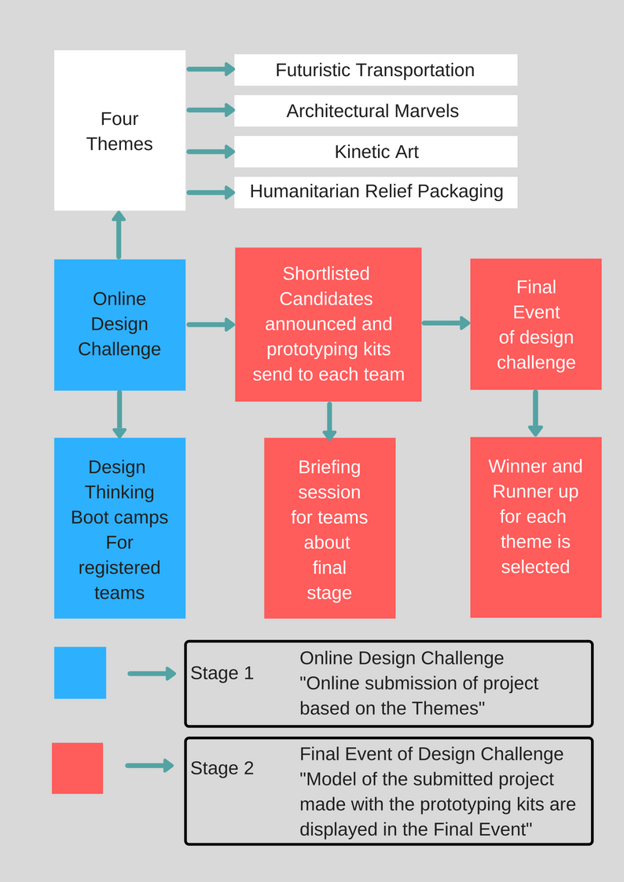

EGA-ADC Important timeline:
(*Adopt similar to the bottom template for the timeline in the website as well as challenge manual)

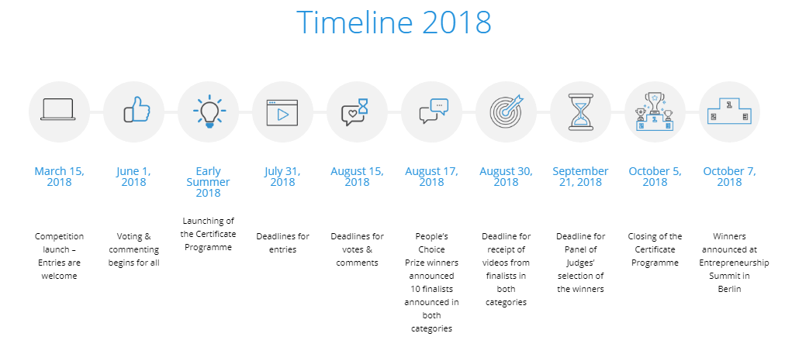
Key Dates and important timelines

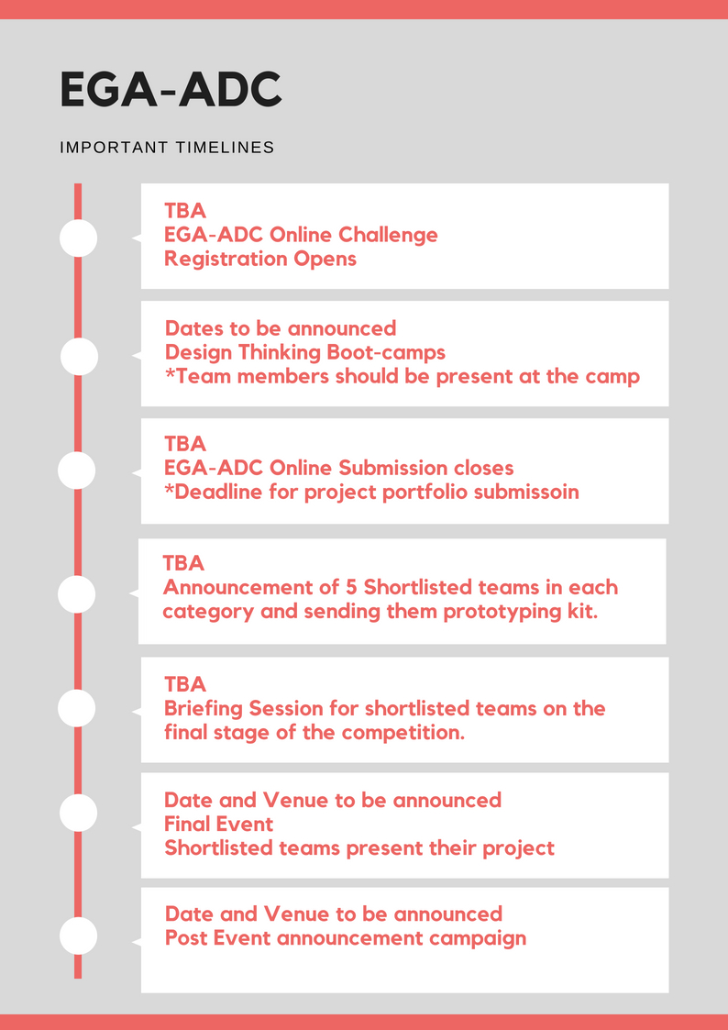

Prizes:

The Winning team from each theme receives a cash prize of AED10,000.

The runner-up team from each category receive a cash prize of AED5,000.

How to enter:

You can enter the design challenge on or before (Enter date) by making submissions in the Award Force online portal, (WEBSITE LINK).

Link to important documents:

Events Rules and Regulations
Submission Criteria
NDA and General Terms
Q & A - Faqs
Contest Disclaimer

The winning design team must have the following criteria:

(Subjective to change as per consultants inputs)

In Futuristic Transportation:

If the transportation is driverless, make sure the right innovation is been used. Also, the winning team will have excellent detailing of:
- Vehicle Shape Plan, exhibiting the vehicle’s exterior look.
- Ergonomics of seating and control
- Chassis Design
- Vehicle component and space for seats.
- Safety considerations

In Architectural Marvel:

The architectural marvel can be buildings, bridges, superstructures, or monument. It must aesthetic as well as serves the purpose.
- Architectural sketches
- Structural Function
- Structural Stability
- Accessibility
- Aesthetics

In Kinetic Art:

The use of energy from natural elements is of importance. Also, the design should be aligned with STEAM conceptual.
- Performance requirements and functionality of the Kinetic Art has been mentioned
- Physical requirements of the product are well defined.
- Aesthetics
- Alignment with STEAM conceptual
- What natural element is used to power the art?

In Human Relief Packaging:

- The practicality of packaging
- Shelf Life of product is improved with the packaging
- The packaging addresses the needs of the user
- Packaging highlights the overall theme by using the right colors, visual metaphors, textures, materials and word choices.

Guide for Teachers:

Use teacher’s support material as a guide to use the challenge’s learning scheme in Design and technology curriculum, STEM clubs, After School program or innovation programs. The teacher’s and team mentors can use this support material to mentor students to complete their student’s portfolio. Download Teacher’s support material at (WEBSITE LINK). Student’s portfolio will be provided upon registration based on the selected theme.

SECTION 2

Introducing Aluminium:

Aluminium (Al), or aluminum, is a silver, soft metal with an atomic number of thirteen and thirteen protons in the nucleus. It constitutes about eight percent of the Earth's land mass. It is the most abundant mineral on Earth after oxygen and silicon.

(Describe introduction of Aluminium using an info graphic)

How was Al first discovered?

Since pure aluminium is very rare to find in nature, the first nodules of Aluminium were produced in the year 1825. In 1807, the English chemist Sir Humphrey Davy underlined the existence of the element arguing that "alum" was the salt of an unknown metal which he said should be called ‘alumium’. Davy tried but was unsuccessful to produce aluminium by electrolyzing a fused mixture of aluminium oxide and potash.

Following Davy’s work, the Danish physicist H.C. Oersted managed to produce the first nodules of aluminium by heating potassium amalgam with aluminium.

It is not even 200 years since the element aluminium was discovered and only 100 years since a viable production process of this metal was established.

Where Aluminium comes from?

To make aluminium the ore (bauxite) must first be mined. The main sources of bauxite are in Australia, South America, and Africa, but other countries including China, Jamaica, India, and the USA also have large amounts of the ore.
Once it has been mined and cleaned, the bauxite is transported to a factory where it undergoes many processes to produce aluminium metal.

Mining and Refining Aluminium

Deposits of bauxite occur as flat layers lying near the Earth's surface covering many miles. Geologists locate these deposits by a method called prospecting. This is simply taking the core samples or drilling in soils suspected of containing the ore. By analyzing the cores, scientists are able to determine the quantity and quality of the bauxite.
After th­e ore is discovered, open-pit mines typically provide the bauxite that will eventually become aluminum. First bulldozers clear land above a depos­it. Then workers loosen the soil with explosives, which bring the ore to the surface. Giant shovels then scoop up the bauxite-rich soil and dump it into trucks, which carry the ore to a processing plant.

The first step in the commercial production of aluminum is the separation of aluminum oxide from the iron oxide in bauxite. This is accomplished using a technique developed by Karl Joseph Bayer, an Austrian chemist, in 1888. In the Bayer process, bauxite is mixed with caustic soda, or sodium hydroxide, and heated under pressure. The sodium hydroxide dissolves the aluminum oxide, forming sodium aluminate. The iron oxide remains solid and is separated by filtration. Finally, aluminum hydroxide introduced to the liquid sodium aluminate causes aluminum oxide to precipitate, or come out of solution as a solid. These crystals are washed and heated to get rid of the water. The result is a pure aluminum oxide, a fine white powder also known as alumina.
Recycling aluminium requires only five percent of the energy that extracting it from ore requires.

Transforming alumina to aluminum oxide and then into aluminum is done by aluminium smelting which is a process based on electrolysis.

The steps in aluminum smelting are described below: (Create a graphical image or include the information in the life cycle of Aluminium illustration.)
- Alumina is dissolved in molten cryolite at 1,000 degrees C (1,832 degrees F). This may seem like an extraordinarily high temperature until you realize that the melting point of pure alumina is 2,054 degrees C (3,729 degrees F). Adding cryolite allows the electrolysis to occur at a much lower temperature.
- The electrolyte is placed in an iron vat lined with graphite. The vat serves as the cathode.
- Carbon anodes are immersed in the electrolyte.
- Electrical current is passed through the molten material.
- At the cathode, electrolysis reduces aluminum ions to aluminum metal. At the anode, carbon is oxidized to form carbon dioxide gas. The overall reaction is:
2Al2­O3 + 3C -> 4Al + 3CO2­
6. Molten aluminum metal sinks to the bottom of the vat and is drained periodically through a plug.

Life Cycle of Aluminium:
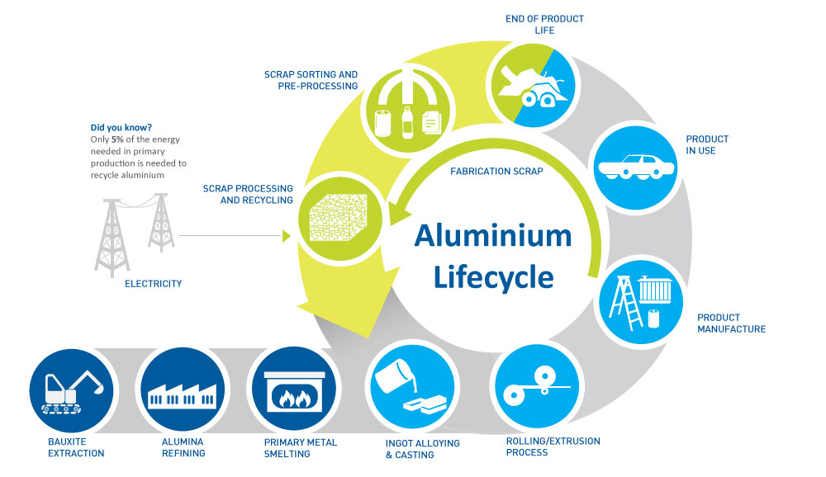
(Create a similar graphical illustration.
Source: https://www.hulamin.com/about/aluminiums-lifecycle)

Advantages of Aluminium

Light Weight
Aluminium is a very light metal with a specific weight of 2.7 g/cm3, about a third that of steel. (EG: Aeroplane)
Corrosion Resistance
Aluminium naturally generates a protective oxide coating and is highly corrosion resistant. (EG: Structure)

Electrical and Thermal Conductivity
Aluminium is an excellent heat and electricity conductor and in relation to its weight is almost twice as good a conductor as copper.
(EG: Power Line, Cookware)

Reflectivity
Aluminium is a good reflector of visible light as well as heat, and that together with its low weight makes it an ideal material for reflectors.
(EG: Mirror)

Ductility
Aluminium is ductile and has a low melting point and density.

Impermeable and Odourless
Aluminium foil, even when it is rolled to only 0.007 mm thickness, is still completely impermeable and let neither light aroma nor taste substances out.
(EG: Tetra Pak, Aluminium Foil)

Recyclability
Aluminium is 100 percent recyclable with no downgrading of its qualities.
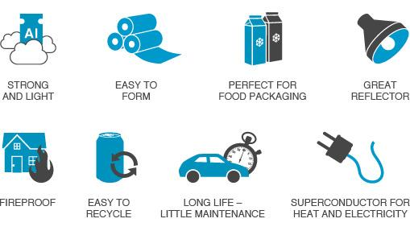
(*Explain each advantage in each page, with the backdrop of the page as an example of usage of aluminium relevant to the advantage or using a graphical illustration. Or use similar info graphics to narrate through each advantage of Aluminium)

SECTION 3
Prototyping your Idea with Aluminium
The teams shortlisted from the initial stage will be provided with a prototyping kit to prototype your idea. This prototype needs to be displayed at the final stage along with posters and supporting project portfolio. Judges will select the Final winner and Runner-up teams for each theme based on these.
The Dimension of Model that can be exhibited at the stand: 1.5sqm x 1.5sqm x 1.5 sqm
Sensors, and Electronics such as DC motor, battery, servos, cannot be included. Kinetic Art should be using natural elements such as light, water, wind, to show movements. Remember the prototype is not even a minimum viable product, a prototype may or may not be a working model. In the case of Kinetic Art, you need to simulate the movement to show the kinetic nature of the prototype. For imitating the natural elements such as wind, water movement, sunlight, etc, you can use the materials provided in the prototyping kit. The it is specifically designed as per the theme challenges.
What is a prototype?
A prototype is an early version of a model, or of a product to be released in the market. It is built to test an idea, a concept or a process. A prototype needs to be tested and re-iterated before turning your idea into a profitable product.
Steps to build your prototype:
- Create a Concept sketch
The first step of turning your idea into reality is paper prototyping. While paper prototyping, you simply sketch your idea on paper. This helps to visualize your idea in a greater detail. Drawing a concept sketch is important as it opens the initial channel of communication to convey your ideas to designers, team members, users and other stakeholders in the first stages of the user-centered design process. Within the prototyping kit, you are provided with a prototyping notebook. Use this notebook, to make an entry of your team’s journey of creating the prototype.
- Develop a virtual prototype
Eventually, you might need to work on creating a digital sketch of your idea to get a better clarity. For this, you can use simpler computer-aided design tools such as Tinkercad or Google SketchUp. In case you require standard designs then you can tool used by engineers such as AutoCAD or Fusion 360 for the same. In case your virtual prototype includes a lot of 2D Design and drafting, AutoCAD is the ideal software. Fusion 360 can also be used for the same, but it is an ideal software for creating engineering based 3D models. You can take print out of your digital design and attach it in the prototyping notebook to mark the progress.
- Build a physical prototype
Once you have designed a virtual prototype, you are ready to build a physical prototype. Make the prototype using the materials provided in the prototyping kit with prime focus in highlighting the maximum usage of Aluminium. Once your first prototype is built, you may find flaws before you finalize your product or idea design. Creating a prototype helps to realize your concept beyond virtual virtualization and it is possible to incorporate changes almost instantly. This helps to cut down cost and time. Imagine finding a design flaw once an architectural structure is built!
- Test, Re-iterate and Build
In case your physical prototype requires further changes, these can need to be reiterated. The teams will be evaluated based on the design thinking process of Empathize, Define, Ideate, Prototype, and Test.

Contents in the Prototyping Kit:
(*Provide a list/table of materials provided within the prototyping kit)
How to prototype with the prototyping kit? (Work in progress)
Let’s Build!
SECTION 4
Design Thinking with Aluminium:
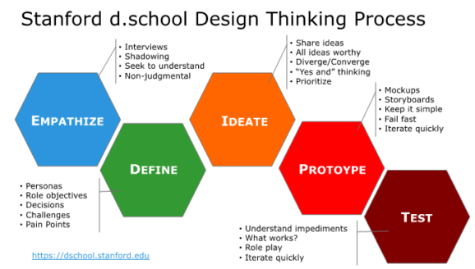
Design Thinking is a design methodology that provides a solution-based approach to solving problems. The project presented should be aligned with design thinking ideology
1. Empathize
The first stage of the Design Thinking process is to gain an empathic understanding of the problem you are trying to solve. This involves consulting experts to find out more about the area of concern through observing, engaging and empathizing with people to understand their experiences and motivations, as well as immersing yourself in the physical environment to have a deeper personal understanding of the issues involved. Empathy is crucial to a human-centered design. Here, empathize the issues you are trying to solve with the project design.

2. Define (the Problem)
During the Define stage, you put together the information you have created and gathered during the Empathize stage. You will analyze your observations and synthesize them in order to define the core problems that you and your team have identified up to this point. You should seek to define the problem as a problem statement in a human-centered manner.
3. Ideate
During the third stage of the Design Thinking process, designers are ready to start generating ideas. These ideas need to be submitted through the online challenge. You’ve grown to understand your users and their needs in the Empathize stage, and you’ve analyzed and synthesized your observations in the Define stage, and ended up with a human-centered problem statement. With this solid background, yourself and your team members can start to 'think outside the box' to identify new solutions to the problem statement you’ve created, and you can start to look for alternative ways of viewing the problem.
4. Prototype
The Shortlisted teams will produce a number of inexpensive, scaled down versions of the idea submitted including the specific features found within the submitted idea, using the prototyping kit provided. They can now investigate the problem solutions generated in the previous stage. These prototypes will be demonstrated in the final stage and the judges will evaluate these prototypes and select a winning and runner-up team from each theme.
5. Test
The winning and runner-up teams can further test their prototypes using the cash prize.

SECTION 5
Applications
Automotives:
For many years the biggest end-use market for aluminium has been the transportation sector. More than a quarter of all aluminium is used in the transport sector. Originally indispensable for its lightweight for the aerospace industry, aluminium is now widely used in cars, buses, coaches, lorries, trains, ships, ferries, aircraft, and bicycles.
Dubai Metro
Dubai Metro extensively uses aluminium in its driverless coaches, depot, and underground stations as roofing solutions.
Shinkansen Japan
Steel and aluminium are the dominant materials used in the construction of train bodies, including the train sideboards, roof, floor panels and cant rails, which connect the floor of the train to the sidewall. Aluminium provides a number of benefits to high-speed trains: its relative lightness compared to steel, easier assembly due to parts reduction, and high corrosion resistance. Though aluminium is about 1/3 the weight of steel, most aluminium parts used in the transport industry are about half the weight of corresponding steel parts due to strength requirements.
Architectural Structures:
At the beginning of the last century, Aluminium was virtually unused in civil engineering, as the metal was too expensive and not produced in sufficient volumes. Everything changed in the 1920s when the electrolysis process reduced the cost of Aluminium by 80%. The metal became extremely popular for finishing roofs and domes and for use in drains and wall panels, as well as for decorative purposes. The first building in which Aluminium was widely used in construction was the Empire State Building, the famous New York skyscraper built in 1931 – and the tallest building in the world until 1970.
Burj Khalifa
The total weight of aluminium used on Burj Khalifa is equivalent to that of five A380 aircraft
Gulf Extrusions Co., one of the largest aluminium extrusion plants in the Gulf, has announced that it has supplied 170 tons of aluminium till date for the Burj Khalifa project, proposed to be the world's tallest building. Gulf Extrusions is the sole supplier of aluminium for the construction of Burj Khalifa and had signed an AED 130 million contract to supply 1,400 metric tons of alloy 6061 and 6063 for the project which is scheduled for completion by 2008.
Esplanade Singapore
The Esplanade is one of the eye-catching buildings in Singapore and a world-class performing arts center. It is made up of two rounded glass domes fitted with over 7,000 triangular aluminium sunshades.
Ferrari World:
The largest Aluminium roof in the world is the roof of the Ferrari World giant entertainment park in Abu Dhabi. It has an area of 200,000 square meters, it is over 700 meters in diameter; the Ferrari logo that you can see in the photo measures an incredible 65 meters in length and covers an area of 3,000 square meters, it is the biggest Ferrari logo ever created.
Humanitarian Packaging:
Aluminium's ability to form any shape and its protective qualities have made it the most versatile packaging material in the world. Aluminium foil is used in the packaging of all types of medications such as pills, capsules, creams, lotions, liquid and powder medications. Aluminium foil offers 100% protection against light, moisture, oxygen and other gases as well as against microorganisms and bacteria. Examples:
Thermal Blankets
Space blankets are made by vacuum-depositing a very precise amount of pure aluminum vapor onto a very thin, durable film substrate.
Food and Medicine Packaging:
The use of aluminum foil laminated paper in a rigid, semi-rigid, and flexible package for in-pack thermal processing permits the selection of package geometries that ensure rapid heating and minimum heat damage during processing. Aluminium foil's unrivaled barrier properties, which can totally exclude moisture, microorganisms, light, oxygen and other gases make it a primary material in the protective packaging of pharmaceuticals.
Kinetic Art:
Designers use aluminium to create Kinetic Art based products or sculptures because it gives them a lot of freedom in choosing the shape for their creations, as well as being easy to process and aesthetically pleasing. Being lightweight, it makes products light yet durable. Make sure the kinetic arts make use of natural elements for it to be propelled.

Arc of Petals (1941)

https://www.guggenheim.org/artwork/745

Octo 2 and 3

https://nerdist.com/giant-kinetic-sculptures-beautiful-and-hypnotizing/

Kinetic Art Table

https://www.kickstarter.com/projects/1199521315/sisyphus-the-kinetic-art-table

SECTION 6
Judging Criteria
The work that the team submit will be judged using the set of rubrics available at the end of the teachers guide or separately in the challenge rubric section. The final score for the initial stage of the challenge is out of 50 with the top five teams in each design theme moving on to the finals stage. All work needs to be entered onto the corresponding portfolio for the chosen theme.
For Futuristic Transport Theme:
Vehicle shape plan, chassis design, vehicle packaging, ergonomics of seating and control panels must be illustrated. If the transportation is driverless, make sure the right innovation is been used.
For Architectural Marvels Theme:
Supporting Architectural sketches and site plan must be present. The structural function, accessibility, and stability must be specified. The architecture must be a superstructure and aesthetically pleasing exteriors.
For Kinetic Art:
The use of energy from natural elements is of importance. Also, the design should be aligned with STEAM conceptual. The performance and physical requirements of the product design, as well as the key manufacturing technologies adopted, are accessed.
Humanitarian Packaging Design Theme:
The submission should the practicality and functionality of the packaging design. The packaging should address the physical or psychological needs of the humanity and keep in check with the longevity, storage and travel requirements of the product for which the packaging is meant for.
How to enter the design challenge
The First stage of the design challenge is online. Participating teams along with their mentor need to register for the challenge at Award Force (website link). Once registered for the challenge, the team should submit their project before the submission deadline. Make sure the submission criteria are met before submission of your project.
Contact Us
In case of any further clarifications, you can find a list of Frequently Asked Questions in the FAQ Page. For further inquiries, you can mail at aluminiumdesignchallenge@gmail.com

SECTION 7
Did you know? (Some key points about Aluminium)
- A single Boeing-747 contains 147,000 pounds (more than 66,000 kilograms) of Aluminum.
- Some of the parts of the airplane's engine that Wright Brothers used were made of aluminum, making it light enough to fly.
- The Empire State Building, constructed in 1930-1932, was the first building to make major use of aluminum components and fabricated structures.
- The total weight of aluminum used on the Burj Khalifa is equivalent to that of five A380 aircraft.
- Recycling aluminum takes only 5 percent of the energy needed to extract new aluminum from ore. About 55 percent of aluminum drink cans made it into the recycling bin.
- Every minute of every day, an average of 113,200 aluminium cans are recycled. An aluminum can take as little as 60 days to return as a new can after recycling.
- Recycling one tonne of aluminium saves the carbon dioxide emissions of driving nearly 27,000 miles.
- Actually, Rubies are simply Aluminum oxide crystals with a few atoms of aluminum replaced by a few chromium atoms.
- Aluminum was classified as a precious metal during the mid-19th century. Napoleon III gave aluminum cutlery to his most distinguished guests; others used gold cutlery.
- Aluminum has the amazing ability to reflect 98% of infrared rays and 92% or visible light. Making it widely used for making reflective mirror surfaces.

SECTION 8
Terms and Conditions
PLEASE REVIEW BELOW CAREFULLY. Entry will be deemed to signify acceptance of the terms and conditions below, including any revisions posted here.

1. The EGA Aluminium Design Challenge is open to students in schools in the United Arab Emirates in Grades 9, 10 and 11 as of 16th September 2018.
2. Entries for the EGA Aluminium Design Challenge are to be in a team of two to four students and one teacher/mentor.
3. The winners in the Finals will be awarded prize money to be shared equally among team members.
4. Maximum of only one entry is allowed per team.
5. Entries can only be made online through the site, Award Force (LINK). Entries must be submitted by the teacher/mentor.
6. Entries should be correctly labeled with the team name and the school name on each page.
7. Entries must cover the three areas shown on each challenge guide: how students are using the Design Thinking process to solve a problem, how they are using aluminium, and …………………...
8. Entries must be a maximum of XXXX pages of A4 and may also include up to 10 images/photos.
9. The judging panel decision will be final, there will be no appeal system and no communication will be entertained on the announced results.
10. No attempt should be made to contact the judges or discussion entered into with the judges either personally or through any persons or medium during or after the challenge regarding the team participation, their entries or the judging criteria.
11. The EGA Aluminium Design Challenge organizers will not be responsible for any inability of a prize winner to accept the specified prize.
12. The EGA Aluminium Design Challenge organizers will not be liable for any change of date or venue of the final event.
13. Travel costs to the boot camps, finalists briefing event or the final event will not be covered by the organizers.
14. The winners may be required to participate in publicity connected with the EGA Aluminium Design Challenge.
15. By entering the EGA Aluminium Design Challenge, students and mentors/teachers give agreement for the details of winners and shortlisted entries to be shared by EGA on its website and associated media channels.
16. This challenge is governed by UAE Law and is subject to the exclusive jurisdiction of the UAE courts.
17. Entries to the EGA Aluminium Design Challenge should not intentionally or unintentionally violate any applicable local, state, national or international law or regulation.

SECTION 9
Appendix
Design thinking process
- Download DT toolkit from here for reference:
https://designthinkingforeducators.com/
- Foil challenge DT Standford: https://dschool.stanford.edu/resources/getting-started-with-design-thinking
https://static1.squarespace.com/static/57c6b79629687fde090a0fdd/t/58ac88a429687fbaf4a81d09/1487702181436/FoilChallenge.pdf
- Shapes - The Aluminium Design Knowledge Hub
http://www.shapesbyhydro.com/
Curriculum Links
https://www.gov.uk/government/publications/national-curriculum-in-england-design-and-technology-programmes-of-study
https://www.stem.org.uk/
https://www.stem.org.uk/resources/elibrary/resource/28125/ideas-resources
Links to learning about Aluminium
- Emirates Global Aluminium
https://www.ega.ae/
- Gulf Aluminium Council
http://www.gulfaluminiumdubai.com

- International Aluminium Institute
http://www.world-aluminium.org
http://www.thealuminiumstory.com
- Aluminum Transportation Group
http://www.drivealuminum.org

- The Council for Aluminium in Building
http://www.c-a-b.org.uk

- Aluminium Packing Recycling Organisation
www.alupro.org.uk

- The Aluminium Federation
www.alfed.org.uk

- European Aluminium Foil Association
- European Aluminium Foil Association
- European Aluminium Foil Association
https://www.alufoil.org/en/home.html

Recycling
- Novelis interactive tour of the recycling process for drink cans
www.novelisrecycling.co.uk
- Think Cans
http://thinkcans.net/think-cans-in-the-classroom
- Recycle Now has information and resources for schools for recycling
www.recyclenow.com/schools/index.html

Manufacturing

- Can Manufacturers Institute (USA)
www.cancentral.com

Links to learning about Innovation and creativity
- edX - Innovation Generation: How to Be Creative
https://www.edx.org/course/innovation-generation-how-be-creative-uthealthsphx-inov101x

